FR4NK5T3R | Jun 15 2006, 03:51 PM  Post #1
  Gizmosized | Ok here's all you need to know to make a versatile add on battery pack for the Gizmondo.  Go to Maplin Electronics and buy the following parts:  1 x four AA battery box HF94C @ £0.49  1 x PP3 clip NE19V @ £0.29  1 x DC Jack 3mm x 1mm AQ86T @ £0.49  1 x Power adapter lead AQ81C @ £0.99  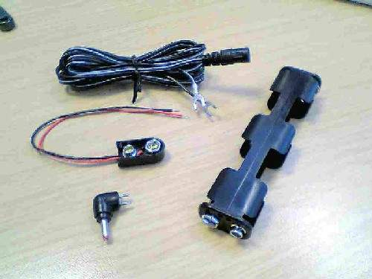  Cut and strip both the Power adapter lead and PP3 clip wires and join the white stripe power wire to the red PP3 wire.  Then join the two blacks together. Tape this up with insulation tape.  Now plug the DC jack into the power adapter lead so that the "+" on the Jack lines up with the word "Tip" on the power  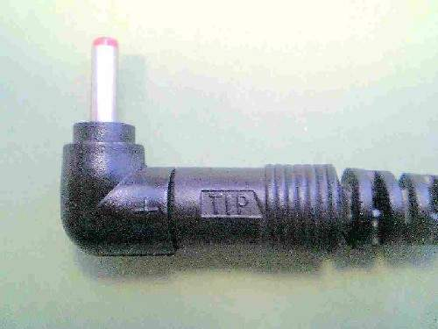  adapter lead. Finally Clip the PP3 clip onto the end of the battery pack  Ok you're done. Now just place four AA batteries, either Alkaline, Nicad or NiMh into the battery pack making sure they  are the correct way round and plug the jack into your Gizmondo.  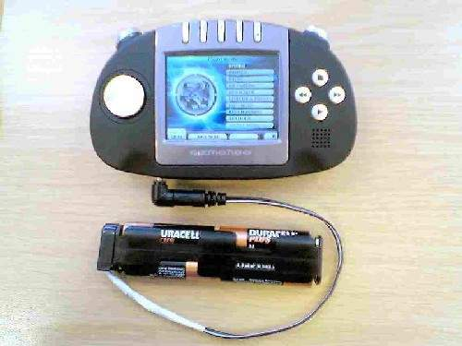  You can of course replace the 4 x AA pack for a 4 x C or 4 x D battery pack but don't be tempted to plug a 9V PP3  into the PP3 clip. You could also use a wall adapter as long as the voltage is around 5 to 6V. I have measured the  current with an empty battery and it is 0.6A. This rules out a USB adapter which was my next idea. (Or Does it?)  --------------------  FR4NK5T3R's Useful Stuff  ********************************************************************************  Other Hardware Guides  Useful Table Stand for watching videos  Mains Charger For The Gizmondo  Car Sunshade/Night time reflection shield Mark II  Multi-Purpose USB Lead  Versatile Battery Pack  Make A Battery For Your Gizmondo  Bypass The Giz's Battery  Simple Sunshade

