FR4NK5T3R | Jun 16 2006, 01:39 PM  Post #1
  Gizmosized | Ok here's how to convert a Sanyo DB-L40 Battery for use in the Gizmondo    Firstly you need the following:  1 x Sanyo DB-L40 Battery. I bought one for under £7 from here DIGITAL-iSHOP  1 x Gold plated Matrix board from Maplin N97CF £1.99 (Don't use normal copper it tarnishes)  3 x pieces of standard 25swg tinned copper wire about 30mm in length  3 x pieces of 30swg enamelled copper wire or pvc insulated wire about 100mm in length  also insulation tape a sharp knife, some cardboard, a hacksaw, some solder and a fine tipped soldering iron  Step one  Cut a piece of matrix board to the shape and size shown. This can be done by using a hacksaw or by simply scoring along the holes with the knife on both sides and carefully snapping the board with a pair of pliers.  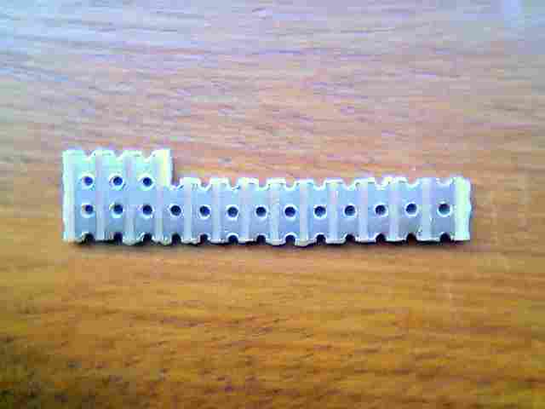  Step two  Take the three pieces of tinned copper wire and make a small right angle bend on the end of each about 2mm long and pre tin it. This creates a foot to solder to the battery. Stand the battery up in a vice or blob of blue tac and pre tin the three contacts. Don't linger too long with the iron as the case will melt. Now solder each wire to a battery contact as shown so that the wire is not in the middle but towards the edge. This helps to line up with the Giz contacts. Be careful not to short the two outer wires when they are connected as the battery could go bang.  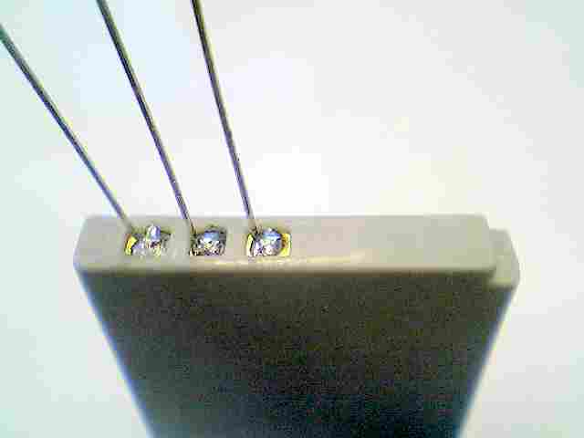  Step three  Carefully line up the wires and slide the piece of matrix board down onto the battery and solder as shown. If you are fairly quick they won't come unsoldered from the battery.  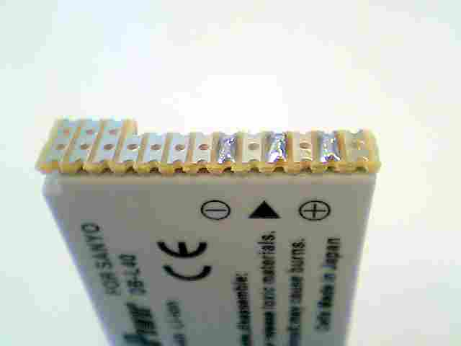  Step four  Take the 3 pieces of enamelled wire, pre tin one end and poke through the holes in the matrix board where it sticks out. Bend them back to the edge and solder. It's important to keep the main contact area clear of solder as this will ruin the gold plating. Now lay the three wires along the battery and cut to correct length to reach battery pins. They are in the same order i.e. the first wire goes to the first pin, the second to the second pin and the third to the third pin. Pre tin and solder these to the top of the matrix board at the appropriate pin.  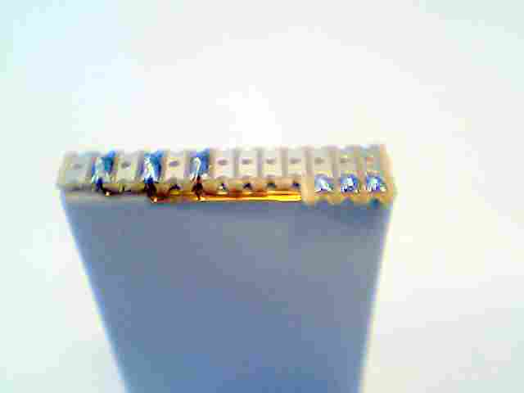  Step five  Cut a 6mm wide strip of card about 85mm long as shown. Bend it at the 35mm point and stick it with tape to the edge of the battery. This is important to push the battery against the Giz terminals.  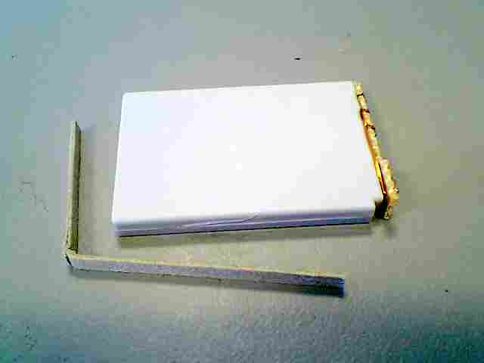  Step six  Offer the battery into the Giz and make sure the contacts line up properly. If not adjust cardboard or push matrix board carefully over as necessary. Finally tape the exposed parts of matrix board leaving the three main contacts clear to make contact with the Giz terminals.  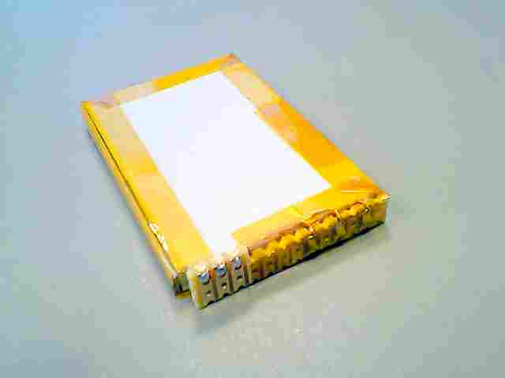  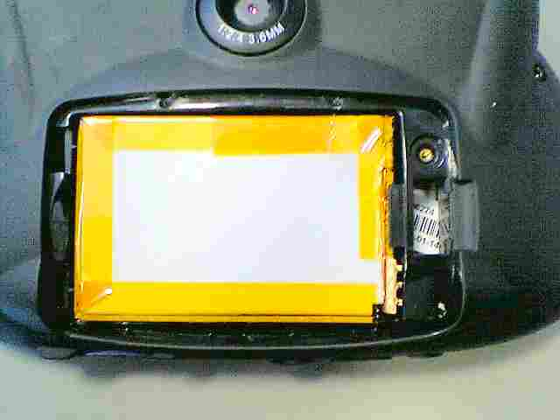  --------------------  FR4NK5T3R's Useful Stuff  ********************************************************************************  Other Hardware Guides  Useful Table Stand for watching videos  Mains Charger For The Gizmondo  Car Sunshade/Night time reflection shield Mark II  Multi-Purpose USB Lead  Versatile Battery Pack  Make A Battery For Your Gizmondo  Bypass The Giz's Battery  Simple Sunshade

